**Insurance Database**

create database 1bm21cs062_insurance;

use 1bm21cs062_insurance;

***Creating table person*:**

create table person (

driver_id varchar (10),

name varchar (10),

address varchar (30),

primary key(driver_id)

);

***Creating table car*:**

create table car (

reg_num varchar (10),

model varchar (20),

year int,

primary key(reg_num)

);

***Creating table accident*:**

create table accident (

report_num int,

accident_date date,

location varchar (10),

primary key(report_num)

);

***Creating table owns*:**

create table owns (

driver_id varchar (10),

reg_num varchar (10),

primary key(driver_id,reg_num),

foreign key(driver_id) references person(driver_id),

foreign key(reg_num) references car(reg_num)

);

***Create table participated*:**

create table participated (

driver_id varchar (10),

reg_num varchar (10),

report_num int,

damage_amout int,

foreign key(driver_id) references person(driver_id),

foreign key(reg_num) references car(reg_num),

foreign key(report_num) references accident(report_num)

);

***Inserting values into table person and displaying:***

insert into person values ('A01','Richard','Srinivas nagar');

insert into person values ('A02','Pradeep','Rajaji nagar');

insert into person values ('A03','Smith','Ashok nagar');

insert into person values ('A04','Venu','N R colony');

insert into person values ('A05','Jhon','Hanumanth nagar');

select * from person;

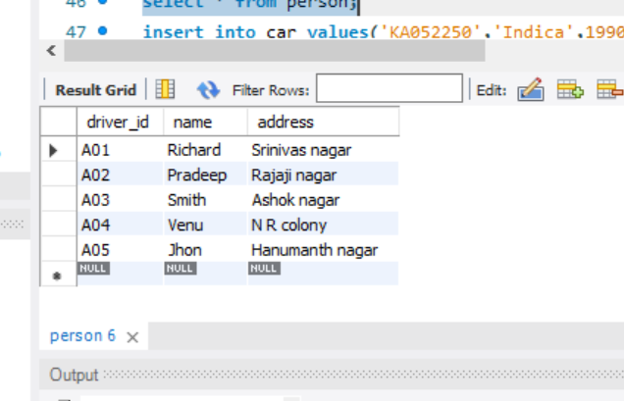

***Inserting values into table car and displaying:***

insert into car values('KA052250','Indica',1990);

insert into car values('KA031181','lANCER',1957);

insert into car values('KA095477','Toyata',1998);

insert into car values('KA053408','Honda',2008);

insert into car values('KA041702','Audi',2005);

select * from car;

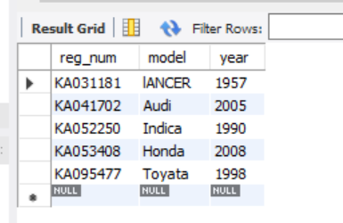

***Inserting values into table accident and displaying:***

insert into accident values (11,'2003-01-01','Mysore Road');

insert into accident values (12,'2004-02-02','South end circle');

insert into accident values (13,'2003-01-21','Bull temple end');

insert into accident values (14,'2008-02-17','Mysore Road');

insert into accident values (15,'2004-03-05','Kanakapura road');

select * from accident;

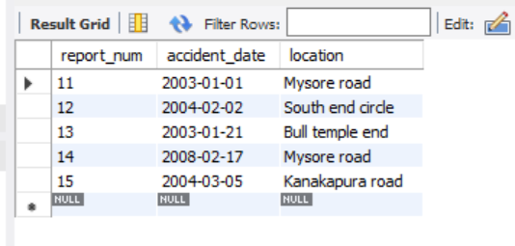

***Inserting values into table owns and displaying:***

insert into owns values('A01','KA052250');

insert into owns values('A02','KA053408');

insert into owns values('A03','KA031181');

insert into owns values('A04','KA095477');

insert into owns values('A05','KA041702');

select * from owns;

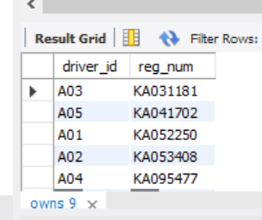

***Inserting values into table participated and displaying:***

insert into participated values('A01','KA052250',11,10000);

insert into participated values('A02','KA053408',12,50000);

insert into participated values('A03','KA095477',13,25000);

insert into participated values('A04','KA031181',14,3000);

insert into participated values('A05','KA041702',15,5000);

select * from participated;

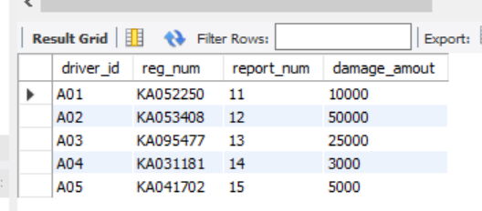

**WEEK 1 – QUERIES**

**1.Update the damage amount to 25000 for the car with a specific regnum (example 'KA053408’) for which the accident report number was 12.**

**SQL>**update participated  
 set damage_amount=25000  
 where reg_num='KA053408' and report_num=12;

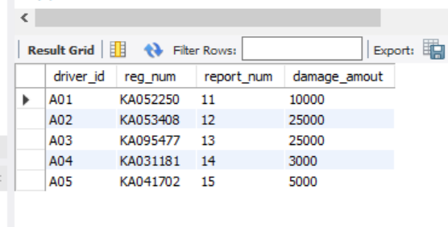

**2.Add a new accident to the database.**

SQL>insert into accident values(16,'2008-03-08',"Domlur");

SQL>select * from accident;

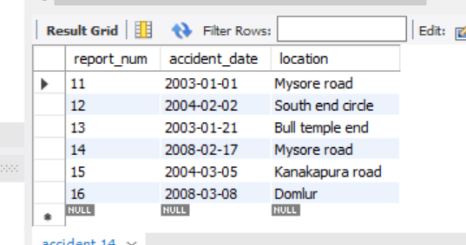

**3.Find the total number of people who owned cars that were involved in accidents in 2008.**

**SQL>** select count (distinct driver_id) CNT  
 from participated a, accident b  
 where a.report_num=b.report_num and b.accident_date like '%08%';

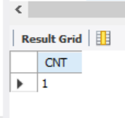

**4.Display Accident date and location**

**SQL>** select accident_date, location from accident;

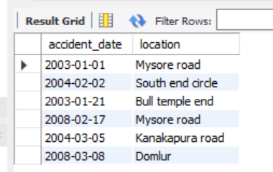

**5.Display driver id who did accident with damage amount greater than or equal to Rs.25000**

**SQL>** select driver_id from participated where damage_amount>=25000;

